Flexible Conductive Diamond Electrodes for Stable, Multifuntional Neural Interfaces

Siyang Wang¹, Sorel E. De Leon^{1,2}, Nadarajah Athavan¹, Toon Goris¹, Negin Jalilinejad¹, Young Jun Jung¹, David Garrett², Michael Ibbotson³, Steven Prawer¹, Wei Tong^{1,4}*

- School of Physics, University of Melbourne, Parkville, VIC, Australia
- School of Engineering, RMIT University, Melbourne, VIC, Australia
- Department of Biomedical Engineering, University of Melbourne, Parkville, VIC, Australia
- Grame Clark Institute, University of Melbourne, Parkville, VIC, Australia

*Corresponding: wei.tong@unimelb.edu.au
Keywords: Diamond, Neural stimulation, Dopamine sensing, Carbon nanotube, Brain-machine interface

Abstract

Neural interfaces that can detect and modulate neural activity are essential for advancing neuroscience and hold promise for treating neurological disorders. However, existing implantable electrodes often have limited lifetimes and are typically limited to one function, such as stimulation, recording, or neurochemical sensing, restricting their applications in closed-loop systems. Here, we introduce flexible, multifunctional neural electrodes that combine high performance, biocompatibility, and long-term stability across all three modalities. By depositing nitrogen-included ultrananocrystalline diamond films on carbon nanotube mats, we created a hybrid platform that combines the excellent biocompatibility and stability of diamond with the flexibility and lightweight properties of carbon nanotube mats. Conformal diamond coating was confirmed by scanning electron microscopy and Raman spectroscopy, and the electrodes showed flexibility and kept their mechanical integrity under repeated bending. The hybrid diamond/carbon nanotube electrodes showed a high charge injection capacity (~17.2 mC cm⁻²) and maintained >98% capacitance after 900 stimulation cycles. These electrodes could support neuronal survival and neurite outgrowth and detect dopamine with a sensitivity of ~2.3 µA µM⁻¹ cm⁻², while resisting biofouling. The same electrode reliably evoked neural responses in the retina and recorded local field potentials in the cortex. Together, these results establish hybrid diamond/carbon nanotube electrodes as a flexible, biocompatible, stable and multifunctional neural interface platform, with strong promise for long-lasting, closed-loop applications.

- Introduction

Neural interfaces provide a direct communication pathway between the nervous system and external electronics, enabling the recording and modulation of neural activities [1, 2]. These technologies are showing increasing potential in clinical applications for treating a range of neurological conditions [3-8]. Recent examples include a brain-to-voice neuroprosthesis that translate neural signals into real-time, intelligent speech synthesis[9] and a brain-spine interface (BSI) that linked electrocorticography (ECoG) signals to spinal cord stimulation for restoring leg movement[7]. Other examples include deep brain stimulation (DBS) electrodes for treatment of Parkinson’s disease[10], and a high density ECoG-based system that enables stable communication for Amyotrophic lateral sclerosis (ALS) patients[11]. In neuroscience research, neural interfaces are widely employed to study the functional organization of neural circuits and are critical tools for answering important questions such as aging, memory, and cognition[6, 12, 13].

Central to these systems are implantable neural electrodes, which are required to deliver reliable electrical performance while maintaining long-term stability and compatibility with neural tissue[14, 15]. However, most existing electrodes have limited lifetime and are designed for a single function. This restricts their application in the closed-loop systems, where real-time detection of neural signals is needed to guide stimulation. Closed-loop operation promises more adaptive therapies and more precise control of neural circuits, but it requires multifunctional electrodes that can integrate sensing and modulation within a single stable platform.

The longevity and functionality of neural interfaces are often limited by the properties of the electrode materials[1, 16]. Conventional electrodes are typically made from noble metals and alloys such as iridium oxide[17, 18], platinum[19, 20], tungsten[21], and gold[22]. While chemically inert under many conditions, these metals are nonetheless susceptible to corrosion in physiological environments, particularly under chronic electrical stimulation and electrochemical sensing applications[23, 24]. Furthermore, metal electrodes exhibit small charge injection capacities (CIC) and high impedances, thereby limiting the effective electrical stimulation of neurons and hindering the signal-to-noise ratio in neural recordings[19, 22].

Conductive polymers, such as poly(3,4-ethylenedioxythiophene) (PEDOT) based materials, have been proposed as alternatives due to their ease of deposition, tunable conductivity, biocompatibility, and favorable electrochemical properties[29-31]. However, the chemical stability of polymer-based electrode materials is limited, compromising their mechanical integrity and electrochemical performance over time[32, 33].

Apart from electrode material degradation, the mechanical mismatch between rigid electrodes and soft neural tissue remains a critical challenge[35-37]. The natural micro-motion of the brain tissue caused by factors such as heart beating, respiration, and limb movement, can induce micro-friction at the interface between electrodes and soft tissues, provoking adverse tissue responses, and thus interrupting the communication and operation between the nervous tissue and the electrodes in chronic applications[39, 40]. Improving the flexibility of the electrodes and their conformity with the tissues can help alleviate these adverse tissue responses and therefore stability limitations[41-44].

In addition to improved stability, flexible electrodes are particularly advantageous in applications involving curved tissue surfaces[45]. Some examples include epiretinal devices implanted adjacent to the retina for electrical stimulation of retinal neurons[46, 47], ECoG devices placed on the cortical surface for stimulation and/or recording[48-50], and peripheral nerve cuffs that wrap around nerve structures[51]. All these applications benefit from conformal interfaces that have better contact with the target tissues, thereby improving recording and sensing fidelity as well as lowering stimulation thresholds.

Carbon-based materials, such as carbon fiber, carbon nanotube, graphene, and diamond, have attracted significant interest as alternative electrode materials due to their favorable mechanical, electrochemical, and biocompatible profiles[30, 52, 53]. Among them, nitrogen-included ultrananocyrstalline diamond (NUNCD) has demonstrated particular promise[54]. NUNCD combines high corrosion resistance and excellent biocompatibility, with tunable electrical conductivity through nitrogen inclusion, which introduces conductive sp²-rich grain boundaries within the diamond matrix[54, 55]. Previous studies have demonstrated that NUNCD supports neuronal adhesion and neurite extension in vitro and remains safe and stable during in vivo chronic implantation[55-57]. After proper surface treatment, NUNCD electrodes show high charge injection capacities up to 4.1 mC/cm² and suitable optoelectrochemical properties for neural stimulation[58, 59]. Therefore, they have been used as the core electrode material in a high-acuity retinal implant for vision restoration[60]. NUNCD electrodes are also capable of recording single-unit in vitro from the retina, and local field potentials in vivo from the visual cortex[61]. For neurochemical sensing, NUNCD electrodes were previously reported for the simultaneous detection of dopamine, ascorbic acid, and uric acid[62, 63].

Despite these advantages, NUNCD electrodes have been primarily fabricated on rigid substrates, such as silicon and polycrystalline diamond[54, 59, 64]. Although effective in acute preparations, concerns remain when using these electrodes in chronic applications. While flexible microelectrodes based on boron-doped diamond have been explored[65-67], few studies have investigated the fabrication of flexible NUNCD surface electrodes[ref]. Compared to the boron-doped diamond, of which is either polycrystalline or nanocrystalline[65-67], NUNCD exhibits smaller grain sizes, which may offer improved mechanical compliance with flexible substrates and therefore be more resistant to cracking during bending or deformation.

In this work, we report a new class of flexible neural interface electrodes created by depositing NUNCD on carbon nanotube (CNT) mats. CNT mats serve as a lightweight, flexible, shapeable, and mechanically robust scaffold that accommodates the deposition of a conformal NUNCD layer. This hybrid architecture combines the stability, biocompatibility and electrochemical performance of diamond with the flexibility and tissue conformity required for high performance, long-lasting neural interfaces. We systematically evaluated the morphology, composition, and electrochemical properties of the NUNCD coated CNT electrodes and assessed their biocompatibility using primary cortical neuron cultures. We further demonstrated their functionality in modulating neural activity through retinal ganglion cell stimulation in the explanted retina, their capability for neural recording in the rat cortex, and their high sensitivity and stability for electrochemical detection of dopamine. Together, these results established flexible NUNCD/CNT electrodes as a robust and multifunctional platform for advancing stable, biocompatible and adaptable neural interfaces.

- Materials and Methods

  - NUNCD deposition on CNT mats

The CNT mats (Tortech NanoFibers) were treated with oxygen plasma in a Diener Femto Oxygen Plasma Cleaner with a 3:1 argon: oxygen plasma at 45 sccm for 10 min. They were then seeded with hydrogen-terminated nanodiamond solution for different periods between 3s and 12 hours before NUNCD deposition. The hydrogen-terminated nanodiamond solution was prepared by first annealing nanodiamonds powder from PlasmaChem GmbH (Cat.No.: PL-D-G01-25g) at 750 °C for 17 hours in argon and hydrogen forming gas (Coregas) using the MTI Wall Furnace (OTF-1200X) and then dispersing the powder in Milli-Q water at a concentration of 1.5 mg/mL. After nanodiamond seeding, the samples were dried with nitrogen and then the NUNCD was deposited through the IPLAS 11 MPCVD system for 1 hour with 79% Ar, 20% N2, and 1% methane (all gases, BOC Australia, purity 99.999%). The stage temperature ranged from 550 °C to 850 °C, while the microwave plasma power was maintained at 1000 W and the pressure at 80 Torr. After NUNCD deposition, the NUNCD/CNT samples were oxygen annealed using pure oxygen (BOC Australia, purity 99.999%) for 20 hours at 420 °C in the MTI Wall Furnace (OTF-1200X).

  - Physical characterization

Scanning Electron Microscopy (SEM, FEI Teneo VolumeScope 3D SEW) was used to observe the surface morphology of CNT mats before and after NUNCD deposition, using beam current and accelerating voltage at 50 pA and 10kV, respectively. Raman Spectroscopy (Renishaw InVia Raman Microscope system, 532 nm) was conducted to characterize the bonding structure of NUNCD samples at room temperature with an exposure time of 10 s. The Jandel 4-Probe station was used to measure the sheet resistivity of the samples.

  - Electrochemical characterization

A three-electrode Teflon chamber was used to characterize the electrochemical properties of the samples, as previously described[68]. The exposed area of the working electrode was defined using a 3 mm diameter O-ring, which was secured between the working electrode and the chamber. The electrical connection between the working electrode and our sample was made by applying silver paste (Sigma) between the sample and a conductive copper plate. A Pt counter electrode and an Ag/AgCl reference electrode were introduced to the electrolyte in the Teflon chamber. Considering the porous structure of CNT mats, a Si wafer (P-type, <100> 200 μm) was placed below the CNT sample to avoid liquid leakage from the CNT mat to the bottom conductive plate. All electrochemical characterization of the electrodes was performed using a Gamry 30054 potentiostat in saline solution (0.15 M NaCl) at room temperature.

All samples, including those used for dopamine detection below, were first treated and stabilised by exposing them to 100 CV cycles of -1 V to 1 V in saline solution at a rate of 150 mV/s. The capacitance of the electrodes was then measured using cyclic voltammetry (CV) by scanning between -100 and 100 mV at rates from 10 to 50 mV/s. The capacitance was estimated as the slope of a linear fit between the current magnitude at a given potential (0V) versus the scan rate[54]. Electrochemical impedance spectroscopy (EIS) was conducted on each electrode using a potential amplitude of 10 mV at frequencies from 0.1 to 10⁵ Hz. The water window was measured by scanning the CV between -2 and 2 V at a scan rate of 100 mV/s.

To examine the electrochemical stability of the electrodes, CNT mats with or without NUNCD coatings were exposed to repeated CVs of -1 V to 1 V in saline solution at a rate of 150 mV/s over another 900 cycles. Capacitance and EIS measurements were taken every 100 cycles.

  - Electrochemical detection of dopamine

The three-electrode electrochemical setup described above was also used for dopamine detection measurements using uncoated CNT and NUNCD coated CNT samples. CVs between -0.4 V and 1 V were applied at a scan rate of 100 mV/s while the electrodes were immersed in PBS and dopamine solutions of varying concentrations between 0.1 and 2 mM. Background currents were removed by subtracting the CV recorded in PBS from each dopamine CV prior to analysis. Dopamine sensitivity was estimated at the slope of the linear fitting between the oxidation peak current and dopamine concentration. The limit of detection (LoD) was determined as:
$$LoD=3.3 \frac{σ}{S}$$
Where $σ$ is the standard deviation of the regression residuals and S is the fitted slope.

Biofouling tests were conducted by incubating samples in PBS solution containing 15% horse serum (HS) at room temperature. During the first 6 hours, electrodes were continuously cycled between -1 V and 1 V at a scan rate of 100 mV/s. No additional CVs were applied thereafter. Dopamine sensitivity was re-measured for individual samples after 6 hours and 22 hours of incubation.

  - Animal Ethics Statement

The procedures in this manuscript were conducted in compliance with the guidelines of the National Health and Medical Research Council of Australia (Australian Code for the Care and Use of Animals for Scientific Purposes) and approval (ID 27269, 27274 or 27122) from the University of Melbourne Animal Welfare and Ethics Committee.

  - Biocompatibility Assessment

Individual uncoated CNT and NUNCD/CNT samples (n=3 per group) with a 5 mm by 5 mm size were attached to a coverslip using biocompatible silicone elastomer (Kwik-CastTM). The carbon samples and coverslip controls were sterilized via autoclaving, and then placed in 48-well dishes for cell culture with three replicates per condition. Prior to cell seeding, carbon samples were incubated in Neurobasal A medium (Gibco) overnight without additional coatings. Coverslip (CS) controls (n=3) were pre-coated with 0.05 mg/ml poly-dl-lysine. The primary rat cortical cells were harvested from cerebral cortices of P0 rat pups and were seeded on the surface of NUNCD/CNT at a density of 100k cells/ well on both NUNCD/CNT and coverslip controls. After seeding, the cells were incubated at 37 °C in a 5% CO₂ environment. Half of the culture medium (Neurobasal A supplemented with B27, Pen/Strep, and GlutaMax) was then changed every two days.

Samples were then fixed after 7 days of incubation to assess the cellular viability and morphology. The samples were washed with phosphorate-buffered solution (PBS) once and then fixed in 4% paraformaldehyde (PFA) solution for 10 min, and then another 10 min in cold methanol. After cold methanol, cells were triple rinsed with PBS. Cells were then pretreated for 30 min with the blocking solution containing 2% goat serum (GS) and 2% fetal bovine serum (FBS) in PBS. Subsequently, the samples were incubated in a primary antibody solution for 30 min and then triple-rinsed with PBS. After the primary antibody solution, samples were incubated with the secondary antibody solution for 60 min. Finally, samples were rinsed with PBS three times and stored in a 4°C fridge to be imaged. The primary antibody solution was prepared with mouse anti-β-III tubulin, and the secondary antibody solution was prepared with Goat anti-mouse Alexa 488 (IgG) together with propidium iodide (PI). Imaging was conducted at at least five random locations per sample using a confocal microscope (Olympus, FV 1200) with the excitation lasers at 488 nm and 532 nm.

For data analysis, cells and neurons were identified manually in ImageJ (Fiji)[69]. Neurite coverage was estimated from β-III tubulin staining using a custom script written in MATLAB R2022b.

  - Electrode fabrication
For retina stimulation and EcoG recording a CNT/NUNCD electrode was fabricated. After successfully depositing NUNCD on CNT the composite mat was cut using a laser cutter (Oxford..) to achieve a 200x200um… The NUNCD/CNT electrode had an exposure area of 200 µm × 200 µm, with the other area covered in epoxy

LoD=3.3 σS

  - Retina stimulation

For the retina preparation, the Royal College of Surgeons (RCS) rat model was used. An RCS rat aged 15 weeks was anesthetized with an intraperitoneal injection using a mixture of Ketamine (100 mg/kg) and Xylazine (10 mg/kg), as previously described. After enucleation of both eyes, 2 µL of calcium indicator solution (20 mM Oregon green 488 BAPTA-1 hexapotassium) was injected into the optic nerve using a Hamilton Syringe through a small incision made at the optic nerve ending. Cornea and lens were removed via hemisection just above the sclera after which the eyecup was maintained overnight in carbogenated Ames’ medium at room temperature. The next day the retina was extracted by severing the optic nerve connection, and the vitreous body was removed via tweezing using a 20× upright stereo microscope (Vision Engineering) under dim red light to prevent photobleaching. The extracted retina was mounted retinal ganglion cell (RGC) side up on a cover slip secured using a tissue harp to flatten and minimize movement over time. The retina was superfused with fresh carbogenated Ames’ medium at room temperature during the entire experiment.

For the calcium imaging, a confocal microscope (Olympus Fluoview FV 1200) outfitted with a 40× water-immersion objective lens (Olympus) was used to acquire fluorescent images at 7.76 Hz. For electrical stimulation, a Grapevine Neural Interface System and a Macro Stim headstage (ripple neuro, USA) were connected to the return silver/silver chloride electrode and the working NUNCD/CNT electrode. Both were placed in the carbogenated Ames’ solution with the return placed at the outer edge of the solution. The electrode was placed epiretinally either on the surface of the retina (~50 µm) or 300 µm away from the retinal surface. The stimulation protocal was run through a custom MATLAB script which was initiated 11 seconds after starting the image acquisition. Each electrical stimulation consisted of a burst of 100 biphasic square wave pulses, with a pulse duration of 0.5 ms and a frequency of 50 Hz. For all experiments the bursts were applied 15 times with a 20 s interval between them. The amplitude of the bursts increased with each individual application ranging from 0-700 µA in steps of 50 µA for close proximity stimulation (~50 µm) and 0-1400 µA in steps of 100 µA for 300 µm, increased distance, stimulation.

For data analysis, cell activity was measured by identifying the location of the RGC soma manually using the Region of Interest Manager in ImageJ (Fiji)[69]. The raw fluorescence intensity spectrum over time was extracted for each individual cell. A custom MATLAB script was used to apply an Asymmetric Least Squares (ALS) smoothing method (lambda= 1000000, p= 0.01, niter= 10) followed by normalization and plotting of the processed signal.

  - In vivo brain recordings

NUNCD/CNT electrodes were placed on the surface of the primary visual cortex (V1) of adult Long-Evans rat anaesthetized with isoflurane (5% for induction, 0.5–1.5% during recordings). Analgesics were administered pre-operatively. A 6×6 mm craniotomy and duratomy were performed to expose the visual cortex, and stainless steel screws were affixed to the skull for grounding. Electrodes were mounted on the stereotaxic frame and carefully positioned on the brain surface. Electrophysiological signals were recorded while animals remained under anaesthesia. At the conclusion of the experiments, animals were euthanized with an overdose of sodium pentobarbital administered intracardially.

Extracellular signals were acquired using a Ripple Neuro system at 30 kHz and visualized in Trellis software. The LFP data stream was downsampled to 1 kHz and filtered with a 4th-order low-pass Butterworth filter at 250 Hz.

Signal processing was performed in MATLAB R2021b (MathWorks, Natick, MA, USA). Sixty-second LFP segments were extracted for analysis. Time–frequency analysis was conducted using short-time Fourier transforms with a 3,000-sample window, 75% overlap, and FFT length matched to the segment size. Power spectrograms were expressed in decibels and visualized for individual channels in the 1–30 Hz range to capture dominant slow cortical oscillations.

Up and Down states were identified following established methods[70-72]. Up states correspond to periods of sustained depolarization and high neuronal activity, whereas Down states reflect network quiescence. Detection was based on three state-sensitive features derived from the LFP: the envelope of the slow oscillation (0.5–4 Hz), the variance of the gamma band (15–100 Hz), and the envelope of the multiunit activity (200–500 Hz). These features were combined using principal component analysis (PCA), and a two-component Gaussian mixture model (GMM) was applied to the first principal component to classify time points as Up or Down states.

The voltage signal-to-noise ratio (vSNR) was computed to quantify signal quality, following established approaches in anaesthetized preparations[73, 74]. vSNR was defined as the ratio between the mean peak-to-peak amplitude of all Up states and the mean standard deviation of all Down states:

$$SNR_{voltage}=\frac{\frac{1}{N}\sum_{i=1}^{N}{\left(P2Pup,i\right)}}{\frac{1}{N^{'}}Σ_{j=1}^{N^{'}}\left(STDdown,j\right)}$$

where $P2Pup, i$ is the peak-to-peak amplitude of the $i^{th}$ Up state, and $STDDown, j$ is the standard deviation of the $j^{th}$ Down state. Higher vSNR values indicate clearer separation between neuronal Up and Down states.

  - Statistical Analysis

All statistical analyses were performed using IBM SPSS Statistics. In Figure 2, group differences were assessed by one-way ANOVA followed by post hoc tests: Dunnett’s test for comparisons between the coverslip control and all other groups, and between the CNT control and each diamond-coated CNT group; and Tukey’s HSD test for pairwise comparisons among the diamond-coated CNT groups. For Figure 3, one-way ANOVA followed by Tukey’s HSD test was used. In Figure 5, differences between the two groups were assessed using unpaired two samples t-test. In Figure S3, one-way ANOVA followed by post hoc tests was used; Tukey’s HSD test for comparisons among all types of samples; and Dunnett’s test for comparison between the CNT control and the rest of the groups. In Figure S4-S5, unpaired two samples t-test was used to assess the differences between the two groups.

- Results and Discussion

  - Successful deposition of NUNCD on CNT mats

Nanodiamond seeding is essential for depositing a uniform layer of high-quality NUNCD on substrates.[75, 76] We first explored the optimal conditions for nanodiamond seeding. CNT mats were first seeded in hydrogen-terminated nanodiamond solution for different durations between 3 seconds and 12 hours. NUNCD was then deposited on CNT mats through the MPCVD. Figure S1a-f shows the optical images of the samples after 1 hour of diamond deposition, which revealed a clear trend that correlated with the seeding duration, where a longer seeding duration led to a larger and more uniform, lighter colored region of coating on the CNT mats. Raman spectroscopy (Figure S1g) suggested that the lighter colored regions had features like NUNCD on silicon (NUNCD/Si). In contrast, the darker colored region showed Raman features like graphite. We therefore used 12 hours of nanodiamond seeding for NUNCD deposition on CNT mats in the subsequent studies.

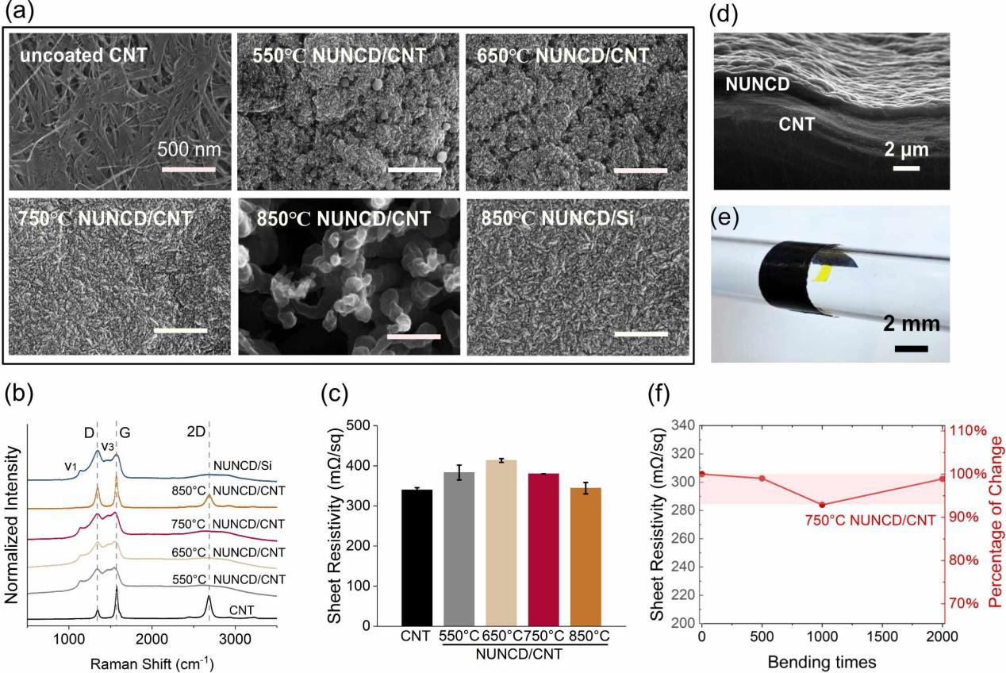
Figure 1. Deposition of NUNCD on CNT mats at different stage temperatures. (a) SEM images of uncoated CNT, NUNCD/CNT deposited at stage temperatures of 550°C, 650°C, 750°C, and 850°C, and NUNCD/Si deposited at 850°C. Scale bars: 500 nm. (b) Raman spectra of CNT, NUNCD/CNT at different preparation temperatures, and NUNCD/Si. (c) Average sheet resistivity of CNT and NUNCD/CNT deposited at different temperatures. (d) Cross-sectional view of NUNCD/CNT deposited at 750 °C. (e) Optical image of the NUNCD/CNT bent around a cylinder with a 4 mm diameter. (f) Sheet resistivity of NUNCD/CNT deposited at 750 °C and the percentage of sheet resistivity change during 2000 times of bending.

Stage temperature is another critical parameter for achieving high-quality NUNCD deposition on various substrates. When depositing NUNCD on Si substrates, we previously demonstrated consistent and high-quality growth using a stage temperature of 850 °C[59, 77], which, however, failed to produce consistent NUNCD deposition on the CNT mats. We therefore explored the effect of stage temperature by depositing NUNCD on CNT mats at varying temperatures between 550 and 850 °C (Figure 1a). SEM (Figure 1a) shows that one hour of deposition, at all temperatures except 850 °C, resulted in the coating on CNT mats with morphology similar to NUNCD/Si. They all exhibit fin-structured morphology as previously reported.[68] In contrast to the porous structures shown in the CNT mats, NUNCD deposited at 550-750 °C exhibited smoother surfaces without pores. Among them, 750 °C deposition led to the most similar morphology to that of NUNCD/Si, while 550 °C and 650 °C resulted in larger islands on the surface. However, 850 °C deposition showed dramatically different morphology with much rougher surfaces and pillared structures.

Raman spectra were obtained to further characterize the chemical structures of the deposition at different stage temperatures (Figure 1b), and the results were compared to the uncoated CNT as well as NUNCD/Si. The samples deposited at 550°C, 650°C, and 750°C all exhibited the typical peaks associated with NUNCD.[78] Specifically, the 550°C-750°C NUNCD/CNT samples all exhibited D (~ 1347 cm⁻¹) and G (~ 1560 cm⁻¹) bands, which are related to the relative motion of sp² carbon and the breathing mode of rings, respectively. The ν1 (~ 1146 cm⁻¹) and ν3 peaks at ~ 1470 cm⁻¹ are considered associated with trans-polyacetylene (TPA) segments at the nanocrystalline diamond grain boundaries.[79] These similarities in Raman spectra between 550°C-750°C NUNCD/CNT and NUNCD/Si again confirm the successful deposition of NUNCD on CNT mats under these conditions. On the other hand, the CNT mats exhibited dramatically different features, with a 2D peak at around ~ 2690 cm⁻¹ in addition to the D (~ 1350 cm⁻¹) and G-modes (~ 1570 cm⁻¹) of the amorphous carbon.[80] The 850 °C NUNCD/CNT showed a similar spectrum to that of the uncoated CNT mats, without the presence of the TPA-related peaks. This further indicated that 850°C exceeded the upper optimal temperature range for NUNCD/CNT deposition. Table S1 summarizes the wavelengths of D, G, TPA-related peaks, as well as the intensity ratio of D and G peaks, noted as I(D)/I(G) ratio. According to these results, the 650 °C NUNCD/CNT exhibited the higher I(D)/I(G) ratio, potentially a lower sp³-bond content, compared to NUNCD/CNT deposited at 550 °C and 750 °C.[79]

Sheet resistance characterization shown in Figure 1c indicated that NUNCD coating decreased the electrical conductivity of the CNT mats, with the sheet resistance peaking when the growth temperature was 650 °C. This is possibly due to the lowest sp³-bond content in 650 °C NUNCD/CNT samples, as shown in the Raman results. Furthermore, the 850 °C NUNCD/CNT showed a similar conductivity to the uncoated CNT mats, possibly due to the higher graphite content as revealed by the Raman results.

We examined the adhesion of NUNCD on CNT using SEM and the cross-section of the NUNCD/CNT deposited at 750 °C. Figure 1d demonstrates the good adhesion of NUNCD on the CNT mat and the resilience of the flexible nature of the sample after deposition. To further confirm its mechanical flexibility, a 750 °C NUNCD/CNT sample was bent repeatedly around a 4 mm diameter cylinder 2000 times (Figure 1e). The sheet resistivity of NUNCD/CNT was measured after every 500 times of bending, which remained 98.8% of the initial value during this bending test (Figure 1f), with no delamination or notable changes in morphology (Figure S2). These results demonstrate the promise of fabricating 750 °C NUNCD/CNT into flexible electrodes.

  - Biocompatibility assessment of NUNCD/CNT

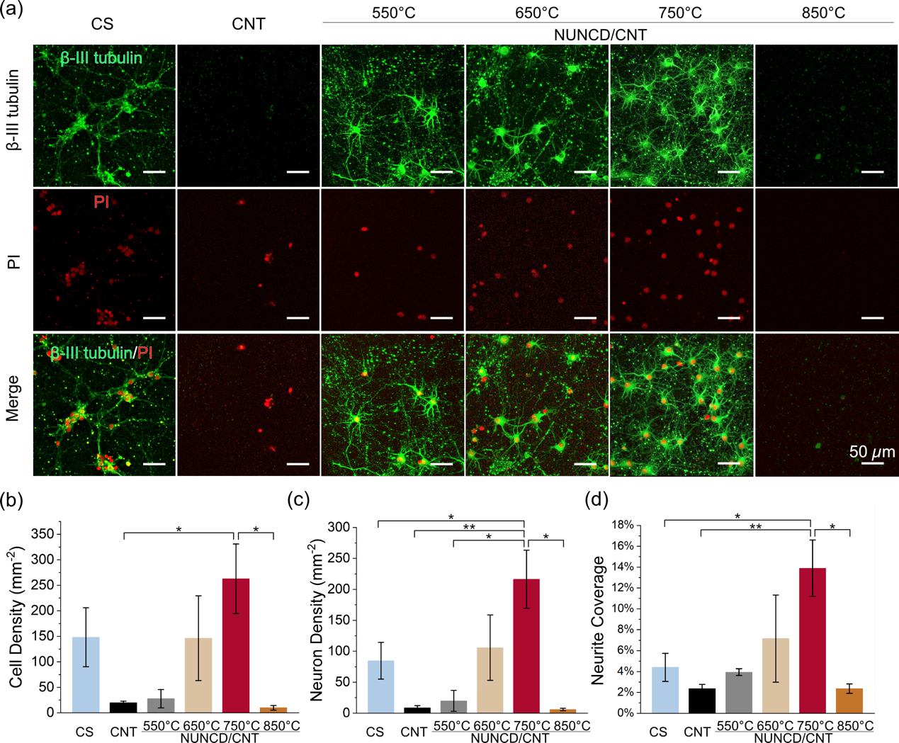
Figure 2. Biocompatibility assessment of CNT and NUNCD/CNT. (a) Representative fluorescent images of the primary rat cortical cells on coverslip (CS) control, uncoated CNT and NUNCD/CNT deposited at 550, 650, 750 and 850 °C after 7 days of cell seeding. Neurons and nuclei were labeled with β-III tubulin (green) and PI (red), respectively. (b-d) Bar charts of cell density, neuron density and neurite coverage of different samples. (Data shown as mean and standard error. *p＜0.05, **p＜0.01)

Biocompatibility is a critical requirement for any implantable electrode material. To assess this, we evaluated the ability of CNT and NUNCD/CNT surfaces to support neuronal survival and neurite outgrowth. Primary neurons were seeded directly onto each surface and cultured for seven days before fixation and immunostaining. Coverslips were pre-coated with poly-D-lysine, whereas no additional coating was applied to the carbon-based materials, as our previous finding suggests that coating is essential for neuronal attachment on coverslips but not on NUNCD/Si[77, 81].

Representative fluorescent images are shown in Figure 2a, with neurons and nuclei labeled by β-III tubulin (green) and PI (red), respectively. Neurons adhered, extended neurites, and formed networks on coverslip controls and on NUNCD/CNT surfaces deposited at 550–750 °C. In contrast, neuronal survival was poor on uncoated CNT and on NUNCD/CNT deposited at 850 °C. Among all groups, the 750 °C NUNCD/CNT surface supported the highest neuronal survival and neurite outgrowth.

Quantitative analysis confirmed these observations (Figure 2b-d). The 750 °C NUNCD/CNT group exhibited significantly higher neuronal density and neurite coverage compared with both the coverslip controls and the uncoated CNT group. The cell density was also significantly higher on the 750 °C NUNCD/CNT compared to uncoated CNT. These results indicated that the NUNCD coating greatly improved the biocompatibility of CNT mats. Within the NUNCD/CNT samples, the 750 °C group also showed significantly better outcomes than the 550 °C and 850 °C groups, while differences relative to the 650 °C group did not reach statistical significance.

Together, these results demonstrate that NUNCD deposition at 750 °C markedly enhances the biocompatibility of CNT mats, yielding surfaces that strongly support neuronal adhesion and neurite outgrowth. Such intimate neuron–electrode interactions are expected to reduce the stimulation threshold and improve the signal-to-noise ratio for recording and sensing. Notably, the morphology of the 750 °C NUNCD/CNT surface closely resembled that of standard NUNCD/Si (Figure 1a), consistent with our previous findings that NUNCD/Si promotes neuronal survival and neurite extension relative to coverslip controls.[81] In earlier work, we also identified a molecular basis for this effect, showing that NUNCD upregulates genes associated with cell adhesion and gap junction communication[77].

  - Electrochemical characterisation of NUNCD/CNT

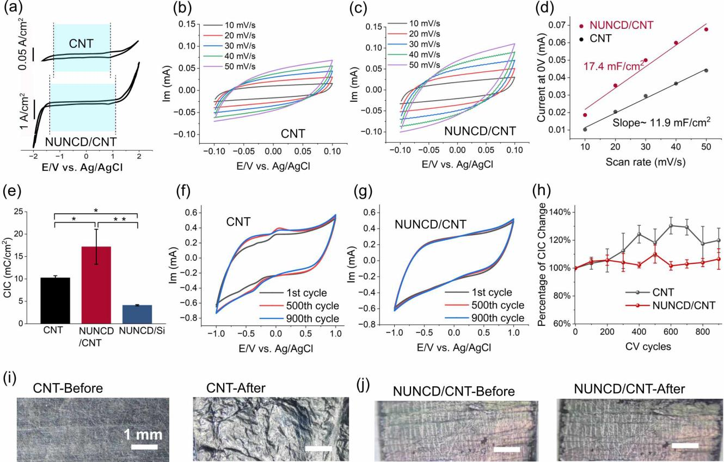

Figure 3. Electrochemical characterization and stability assessment of CNT and NUNCD/CNT (deposited at 750 °C). (a-c) representative CVs recorded using the uncoated CNT and NUNCD/CNT in saline solution, (a) from -2 to 2 V with water windows are highlighted in blue, and (b-c) from -0.1 to 0.1 V at varying scan rates; (d) The current magnitude at 0 V for CVs shown in (b-c) plotted versus the scan rate, with their fitting lines. (e) Charge injection capacitance (CIC) of CNT (n=3), NUNCD/CNT (n=6) and NUNCD/Si[58]. (f-g) Repetitive CVs recorded in saline during 900 cycles at a 150 mV/s scan rate for (f) CNT and (g) NUNCD/CNT. (h) Percentage of CIC change for CNT (n=3) and NUNCD/CNT (n=3) during 900 CV cycles stability test. Data shown as mean and standard error. (i-j) Representative optical images of the CNT and NUNCD/CNT before and after the CV repeats stability test.

Charge injection capacity (CIC) is a critical metric for assessing the suitability of an electrode material for neural stimulation. To assess the CIC of NUNCD/CNT electrodes, we first measured their electrochemical water window (Figure 3a), followed by the determination of their electrochemical capacitance (Figure 3b-e).

In saline solution, CNT mats exhibited a water window ranging from -1.25V to 0.95 V. NUNCD/CNT electrodes deposited at 550-750 °C demonstrated a slightly broader water window of -1.35 V and 1.15V, similar to reported values for NUNCD/Si[68]. For subsequent CIC calculations, we used a window of 0.9 V for CNT and 1.1 V for NUNCD/CNT.

Electrochemical capacitance was quantified by performing CVs in saline between -0.1 V and 0.1 V at varying scanning rates (Figure 3b,c). Capacitance values were extracted by linearly fitting current amplitude at 0 V versus the scan rate (Figure 3d), following established protocols.[68] Among NUNCD/CNT deposited at various temperatures, 750 °C NUNCD/CNT exhibited the highest capacitance (Figure S3). Given that 750 °C NUNCD/CNT also showed morphology most like NUNCD/Si, we selected the 750 °C NUNCD/CNT as the representative sample (hereafter referred to as NUNCD/CNT) for further analysis.

CIC was calculated as the product of the water window and the electrochemical capacitance. As shown in Figure 3e, NUNCD/CNT exhibited a significantly higher CIC (17.2±3.9 mC/cm²) compared to both uncoated CNT (10.2±0.5 mC/cm²) and NUNCD/Si (4.1±0.1 mC/cm²). To our knowledge, this represents the highest CIC value reported for an NUNCD-based electrode to date, which is also two orders of magnitude larger than a conventional Pt electrode, which has a CIC of ~0.15 mC/cm²[82].

The electrochemical stability of the electrodes was subsequently examined by subjecting them to 900 CV cycles in saline between -1 V and 1 V range as shown in Figure 3h. CIC was remeasured every 100 cycles. Uncoated CNT electrodes exhibited a progressive increase in capacitance, reflected by the expanding CV area, reaching approximately 120% of their initial value after 900 cycles. This was accompanied by visible swelling of the CNT mats due to electrolyte infiltration and morphological changes (Figure 3i). Such structural inflation could be problematic for chronic implants as micromotion and volumetric shifts may alter the electrode/neuron distance or even damage surrounding tissue.

In contrast, NUNCD/CNT remained electrochemically stable throughout this process. CV curves showed minimal change across cycles, and the average CIC varied by less than 6.6% over the course of 900 cycles. No delamination or surface degradation was observed, highlighting the robustness of the NUNCD coating and its potential for long-term neural stimulation applications.

Figure S5a-b showed that CNT electrode exhibited a slightly lower impedance at 1kHz (399±41.8) Ohm than NUNCD/CNT electrodes (426±16.9) Ohm. While NUNCD/CNT electrodes displayed a slightly better impedance stability than CNT electrodes (Figure S5c), with the average impedance variation remaining within 4.2% of its initial after 900 CV cycles, indicating its suitability for prolonged neural recording applications.

  - Neural stimulation and recording using NUNCD/CNT electrode

Previous figure:
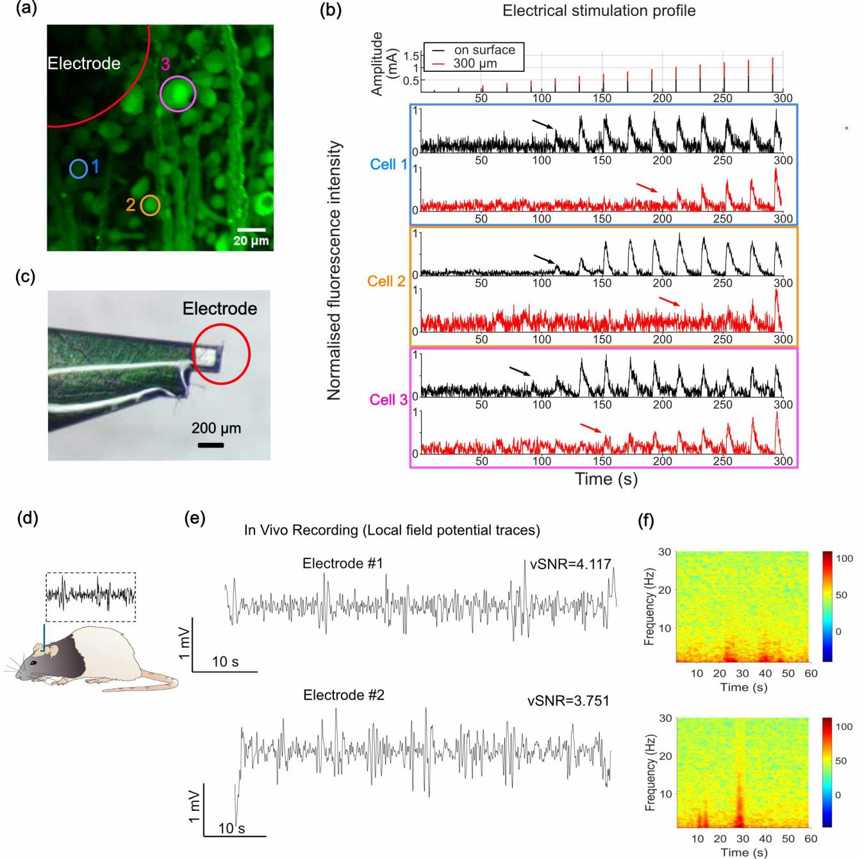

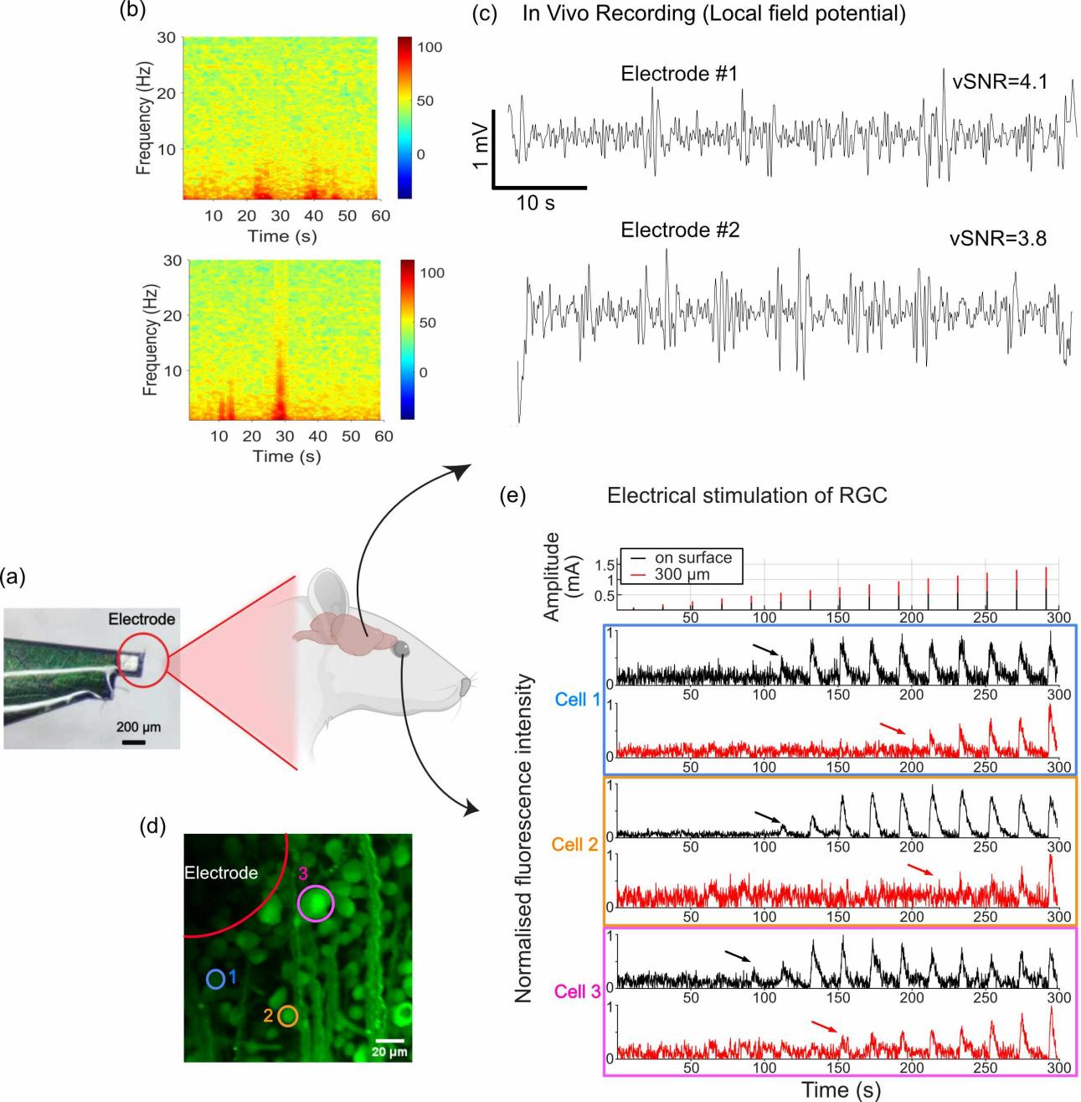Figure 4. Electrical stimulation of RGC and in vivo recording of local field potential with NUNCD/CNT (deposited at 750 °C) stimulation and recording electrodes. (a) Confocal image of calcium indicator stained RGC, in which somas were identified. (b) Electrical stimulation amplitude profile and the corresponding fluorescence response of the marked RGCs (blue, orange, pink). The black signal represents the intensity during epiretinal stimulation while the electrode was on the retina, and the red signal represents the same signal while stimulating from a 300 µm distance. (c) Image of the NUNCD/CNT electrode with the active area of the electrode indicated by a red circle. (d) Recording of local field potential activity using NUNCD/CNT electrodes. (e) Filtered local field potential (LFP) signals from two electrodes, showing slow oscillatory activity with amplitudes reaching ~1mV. Electrode #1 with vSNR of 4.1 and Electrode #2 with vSNR of 3.8. (f) Power spectrogram corresponding to the filtered signals in (e) reveal prominent activity below 10Hz (highlighted by the power density in red), a pattern commonly observed in anaesthetized recordings.

We fabricated NUNCD/CNT into 200 µm square-shaped electrodes and evaluated the potential of using the same electrodes for neural recording and stimulation (Figure 4a).

To evaluate their recording capability of the electrodes, we placed two of them on the surface of the visual cortex of an anaesthetized rat for ECoG recordings (Figures 4d-f). Both electrodes #1 and #2 successfully detected spontaneous local field potentials (LFPs) characterized by slow oscillatory activity, as expected under anaesthesia. Representative filtered traces from each electrode (Figure 4e) revealed robust LFP signals with amplitudes approaching 1 mV. These oscillations exhibited alternating Up and Down states, reflecting periods of network activation and silence. Power spectral analysis of the same recordings (Figure 4f) demonstrated dominant activity in the slow frequency band (< 4 Hz) and additional power extending into the > 10 Hz range, consistent with spectral signatures typically observed in anaesthetized cortex.

To further assess recording quality, we computed the voltage signal-to-noise ratio (vSNR). vSNR was defined as the ratio of the mean peak-to-peak amplitude during Up states (high neural activity) to the mean standard deviation of Down states (background noise). Across both electrodes, vSNR values (4.1 and 3.8) indicated clear separation between oscillatory activity and background noise, confirming the ability of NUNCD/CNT electrodes to reliably capture physiologically relevant cortical dynamics.

The stimulation capability of the electrodes was evaluated by placing the electrode on an explanted whole-mount retina and calcium imaging. Electrode #1 was placed epiretinally either on the surface or at a distance of 300 µm away from the RGC layer. Three example cells are shown in Figure 4a, and their responses to stimulation with increasing amplitudes are illustrated in Figure 4b.

When the electrode was placed on the retinal surface, the three cells responded with onset at 91 s (pink) and 111 s (blue, orange), corresponding to stimulation currents of 190 µA and 230 µA, respectively (black graphs, Figure 4b). In contrast, when the electrode was positioned at 300 µm above the retina, the same cells were activated with onset at 151 s (pink), 211 s (blue) and 221 s (orange), requiring substantially higher current amplitudes of 750 µA, 1050 µA, and 1150 µA, respectively (red graphs, Figure 4b).

This significant increase in activation threshold with distance is attributed to the rapid decay of electric field strength as the distance from the electrode increases. Therefore, higher current amplitudes are required to reach threshold values for neural activation at increasing distances. These results further highlight the importance of using electrodes with high charge injection capacity for effective stimulation. They also highlight the advantage of flexible electrodes that can conform closely to the surface of the neural tissue, minimizing the distance between the electrode and target neurons.

  - Electrochemical assessment of NUNCD/CNT for dopamine sensing

Abnormal dopamine signaling is associated with several neurological disorders, most notably Parkinson’s disease[83]. Real-time detection of dopamine could provide a direct biomarker for closed-loop DBS, where stimulation parameters are adaptively adjusted based on ongoing neurochemical feedback[84]. We therefore focused on dopamine sensing to demonstrate how NUNCD/CNT electrodes could integrate chemical detection with electrical interfacing for closed-loop controls.

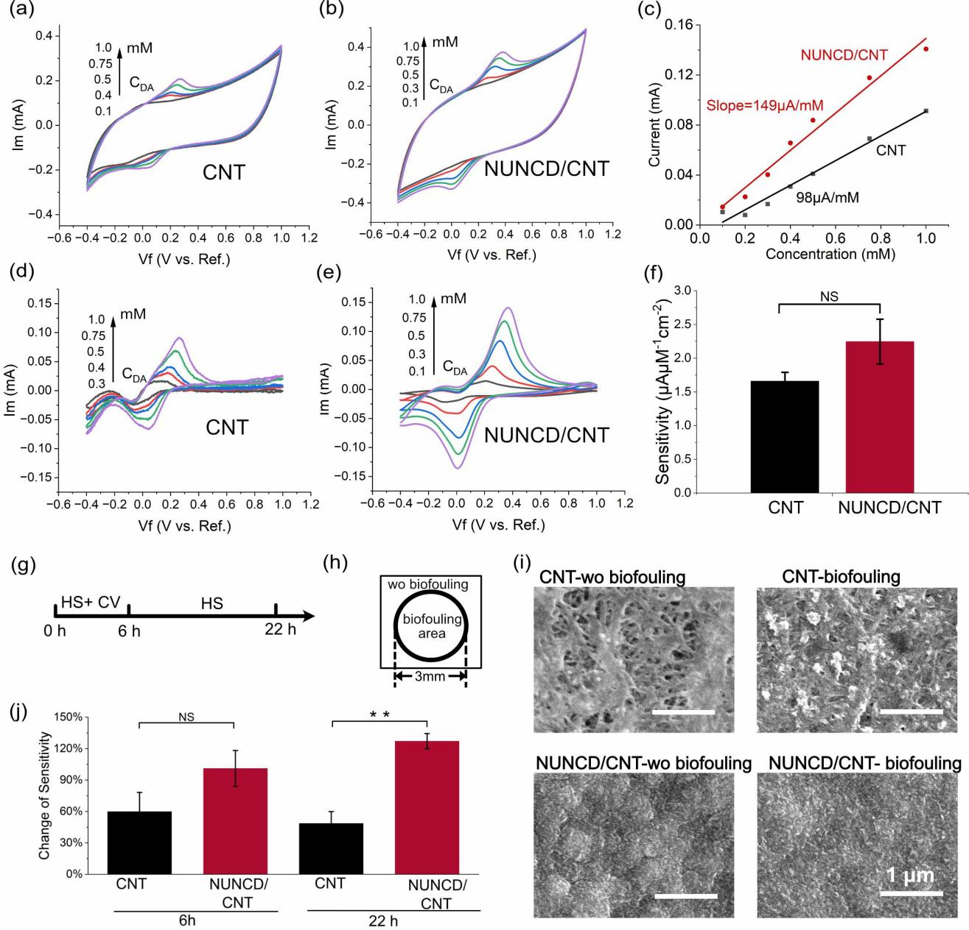
Figure 5. Dopamine sensing capability and biofouling resistance of CNT and NUNCD/CNT (deposited at 750 °C). (a,b) Representative CVs of (a) CNT mat and (b) NUNCD/CNT in dopamine solutions (0.1-1 mM). (d,e) Background subtracted CVs corresponding to (a,b). (c) Linear fits of oxidation peak current versus dopamine concentration for CNT and NUNCD/CNT. (f) Dopamine detection sensitivity of CNT (n=5) and NUNCD/CNT (n=5). (g) Schematic timeline of the biofouling test. Samples were immersed in 15% horse serum (HS) solution thorough the test, with repeated CVs in the first 6 hours. (h) Schematic diagram of regions shown in (i); (i) SEM images of electrode surfaces without biofouling and after 22 hours of biofouling; (j) Percentage change in sensitivity of CNT(n=3) and NUNCD/CNT (n=4) after different biofouling durations; Data shown as mean and standard error.( NS: p>0.05; **p<0.01.)

Representative CVs measured using CNT and NUNCD/CNT electrodes in dopamine solutions of increasing concentrations are shown in Figure 5a,b. Both electrodes displayed clear oxidation and reduction peaks above 0.3 mM, and their oxidation peak potentials shifted as dopamine concentration increased. After background current subtraction (Figure 5d,e), the oxidation peak currents were plotted against concentration (Figure 5c), yielding linear calibration curves. The dopamine detection sensitivity of NUNCD/CNT was 2.3±0.3 μAμM⁻¹cm⁻², which showed no statistical difference from uncoated CNT (1.7±0.1 μA/mM))(Figure 5f, p=0.226). The LoD was 0.30±0.14 mM for NUNCD/CNT and 0.32±0.07 mM for uncoated CNT, respectively (Figure S5a).

The stability of dopamine sensing under physiological conditions was assessed by incubating NUNCD/CNT (deposited at 750 °C) and uncoated CNT in PBS with 15% horse serum (HS) for 6 and 22 hours at room temperature, with CVs from -1 to 1 V applied at a 100 mVs⁻¹ scan rate during the first 6 hours (Figure 5g). Dopamine sensitivity and LoD were evaluated after each incubation period. After 6 hours of incubation, CNT retained only ~60% of their initial sensitivity, whereas NUNCD/CNT electrodes maintained ~99.5%, although the difference was not statistically different (p=0.16). After 22 hours of incubation, NUNCD/CNT sensitivity increased to ~133% of its initial value, while CNT degraded further to ~48.6%. Consistent trends were observed for the changes in LoD Figure S5b). After 6 hours, the LoD of CNT increased to 127% of the initial value, while NUNCD/CNT improved slightly to 85%. After 22 hours, CNT’s LoD further deteriorated to 234%, while NUNCD/CNT remained stable at 88% of the initial value, showing a significant difference between two electrode types (Figure S5b).These results highlight the superior stability of NUCND/CNT in protein rich environment, likely reflecting reduced protein adsorption and biofouling compared to CNT mats .

SEM images were obtained to further characterize the morphological changes upon continuous exposure to physiological conditions. Figure 5h-i showed the regions exposed to PBS with HS (-biofouling) and the unexposed regions (-wo biofouling). It was visible that after 22 hours of biofouling, CNT was covered by deposited material, most likely due to the protein absorption in the porous structures. This fouling likely accounts for the progressive loss of dopamine sensitivity observed for CNT mats. In contrast, NUNCD/CNT electrode showed minimal visible protein deposition, supporting their improved resistance to biofouling.

- Conclusion

NUNCD was uniformly deposited on CNT mats. Biocompatibility assessment with primary cortical neurons demonstrated that NUNCD deposition markedly enhances the biocompatibility of CNT mats, yielding surfaces that strongly supported neuronal adhesion and neurite outgrowth. NUNCD/CNT exhibited an average charge injection capacity of ~17 mC/cm², significantly larger than NUNCD/Si. They also exhibited long-term stability, with CIC variation remaining within 6.6% of their initial values after 900 CV cycles, indicating its suitability for prolonged neural stimulation. NUNCD/CNT electrode successfully evoked neuronal activity in explanted retina tissue and recorded LFPs from rat cortex. For electrochemical sensing of dopamine, the NUNCD/CNT displayed average ~2.3 µA µM⁻¹ cm⁻² sensitivity and demonstrate long-term anti-biofouling property. Overall, NUNCD coated CNT electrodes show improved flexibility, electrochemical properties and stability for neural stimulation, neurochemical sensing and electrophysiological recording. Future work will fabricate them into electrode arrays and validate their performance in more biological models.

Acknowledgement: This work was supported by an ARC DECRA project (DE220100302). This work was performed in part at the Melbourne Centre for Nanofabrication (MCN) in the Victorian Node of the Australian National Fabrication Facility (ANFF). S.E.D. is supported by an Ideas Grant from the National Health and Medical Research Centre (NHMRC, 2038179).

Supplementary information

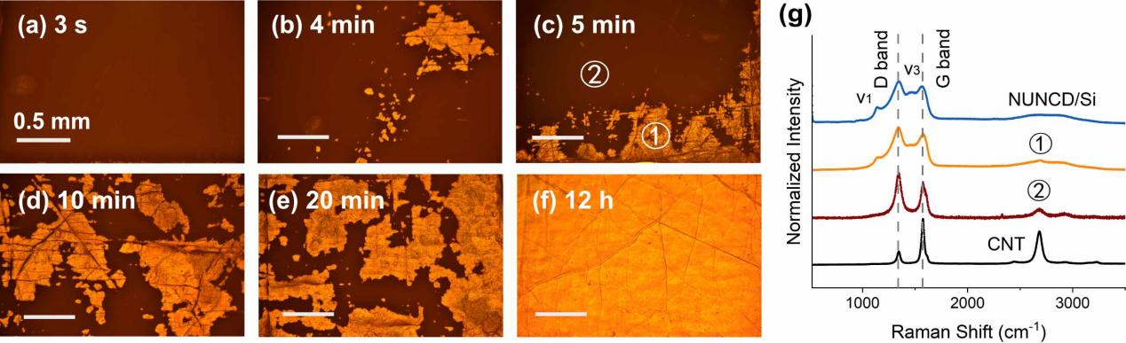
Figure S1. Deposition of NUNCD on CNT mats with different nanodiamond seeding durations. (a-f) Optical images of the sample surfaces after 1 hour deposition with different seeding durations from 3 sec to 12h. Scale bars are 0.5 mm. After deposition, there are both ①light and ②dark patches on the surface. (g) Raman spectra of the ①light and ②dark patches on the as-grown NUNCD/CNT in b-e, compared with NUNCD/Si and CNT. This indicates that lighter patch regions are NUNCD.

Table S1: Raman Characterization in this work.
Sample | D (cm⁻¹) | G (cm⁻¹) | I(D)/I(G) | ν1 (cm⁻¹) | ν3 (cm⁻¹)
Uncoated CNT | 1345 | 1576 | 0.29 | × | ×
550 ºC  NUNCD/CNT | 1349 | 1545 | 0.95 | 1136 | 1473
650 ºC  NUNCD/CNT | 1351 | 1559 | 0.98 | 1140 | 1495
750 ºC  NUNCD/CNT | 1338 | 1551 | 0.95 | 1147 | 1487
850 ºC  NUNCD/CNT | 1351 | 1571 | 0.65 | × | ×
NUNCD/Si | 1341 | 1571 | 1.13 | 1147 | 1468

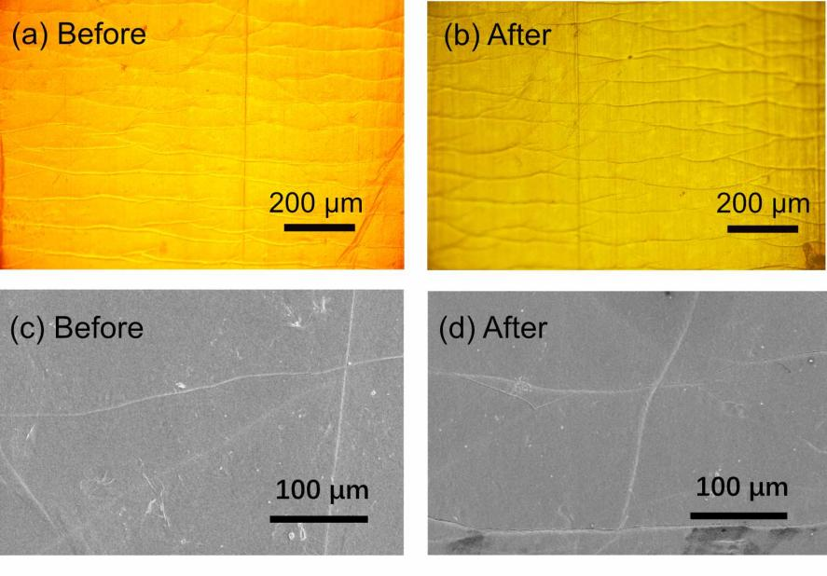
Figure S2. Optical and SEM images of NUNCD/CNT (deposited at 750 °C) before and after bending. (a,b) Optical and (c,d) SEM images of NUNCD/CNT before and after 2000 times of bending, with no noticeable difference.

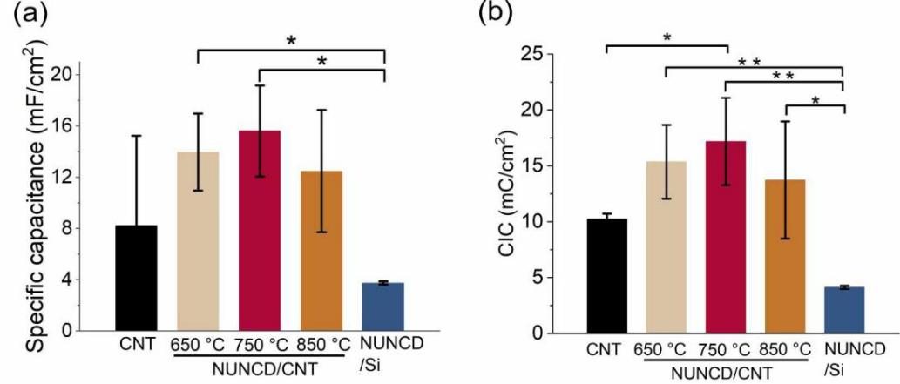

Figure S3. Electrochemical characterization of NUNCD/CNT at different deposition temperatures. (a) Specific capacitance and (b) CIC of CNT mats (n=3), NUNCD/CNT at 650°C (n=4), 750°C(n=6), 850°C(n=4), and the NUNCD/Si (n=3). (Data shown as mean and standard error. *p＜0.05, **p＜0.01)

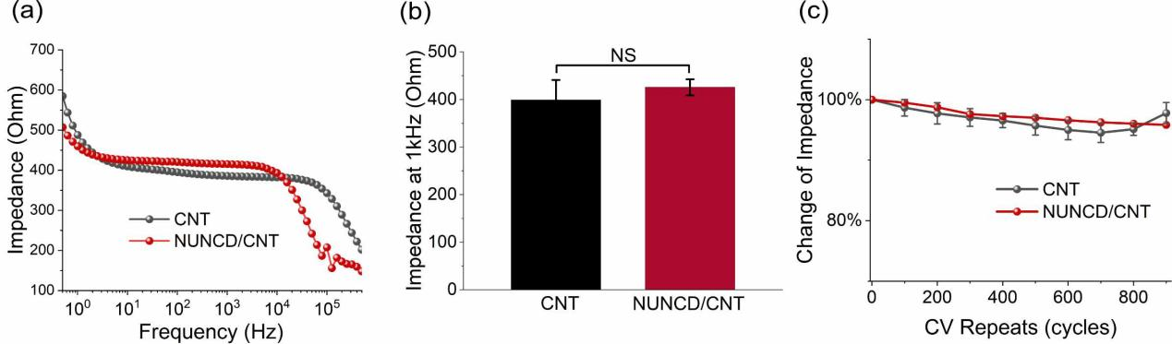
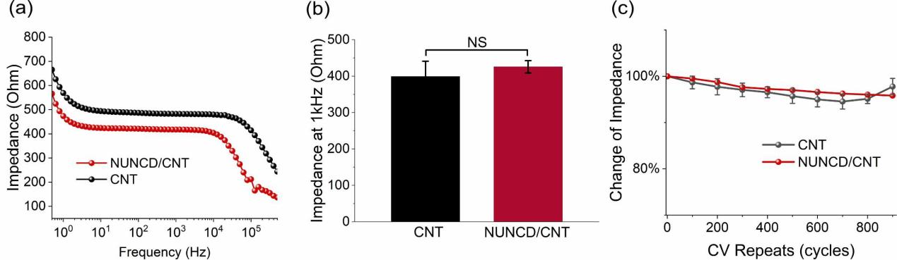

Figure S4. Impedance measurement. (a) Electrochemical impedance spectroscopy (EIS) of CNT and NUNCD/CNT electrode. (b) Bar chart of impedance at 1kHz of CNT (n=3) and NUNCD/CNT (n=6) electrodes. (c) Percentage of impedance change for CNT (n=3) and NUNCD/CNT (n=3) during 900 CV cycles stability test. Data shown as mean and standard error. (NS: p>0.05)

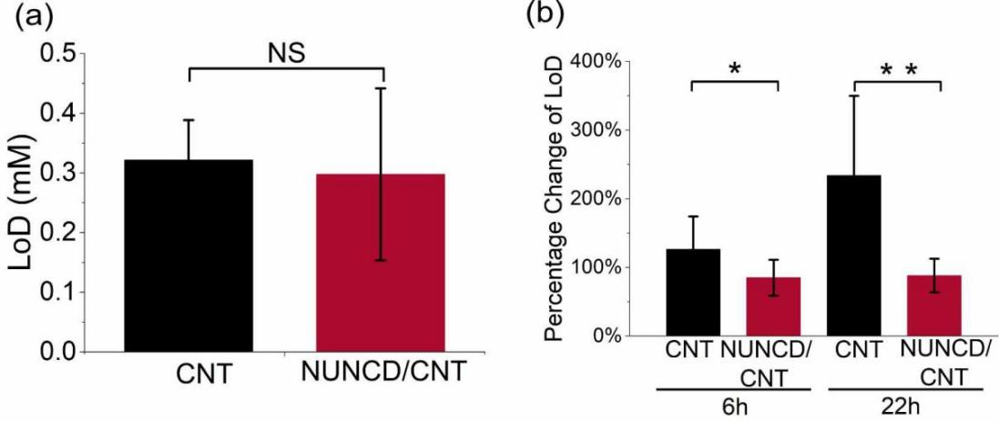

Figure S5. Limit of detection of CNT and NUNCD/CNT (deposited at 750 °C) for dopamine sensing. (a) Detection limit (LoD) of CNT and NUNCD/CNT; (b) Percentage of LoD change after different durations of biofouling for CNT (n=3) and NUNCD/CNT (n=4). Data shown as mean and standard error. (NS: p>0.05, *p＜0.05, **p＜0.01)

References

[1] H.B. Li, J.F. Wang, Y. Fang, Recent developments in multifunctional neural probes for simultaneous neural recording and modulation, Microsystems & Nanoengineering 9(1) (2023).
[2] A.M.M. Sousa, K.A. Meyer, G. Santpere, F.O. Gulden, N. Sestan, Evolution of the Human Nervous System Function, Structure, and Development, Cell 170(2) (2017) 226-247.
[3] M. Arlotti, M. Colombo, A. Bonfanti, T. Mandat, M.M. Lanotte, E. Pirola, L. Borellini, P. Rampini, R. Eleopra, S. Rinaldo, L. Romito, M.L.F. Janssen, A. Priori, S. Marceglia, A New Implantable Closed-Loop Clinical Neural Interface: First Application in Parkinson's Disease, Front Neurosci 15 (2021) 763235.
[4] N.C. Swann, C. de Hemptinne, S. Miocinovic, S. Qasim, J.L. Ostrem, N.B. Galifianakis, M.S. Luciano, S.S. Wang, N. Ziman, R. Taylor, P.A. Starr, Chronic multisite brain recordings from a totally implantable bidirectional neural interface: experience in 5 patients with Parkinson's disease, J Neurosurg 128(2) (2018) 605-616.
[5] P. Romanelli, M. Piangerelli, D. Ratel, C. Gaude, T. Costecalde, C. Puttilli, M. Picciafuoco, A. Benabid, N. Torres, A novel neural prosthesis providing long-term electrocorticography recording and cortical stimulation for epilepsy and brain-computer interface, J Neurosurg 130(4) (2019) 1166-1179.
[6] J.J. Ferrero, A.R. Hassan, Z.L. Yu, Z.F. Zhao, L. Ma, C.Y. Wu, S. Shao, T. Kawano, J. Engel, W. Doyle, O. Devinsky, D. Khodagholy, J.N. Gelinas, Closed-loop electrical stimulation prevents focal epilepsy progression and long-term memory impairment, Nat Neurosci (2025).
[7] H. Lorach, A. Galvez, V. Spagnolo, F. Martel, S. Karakas, N. Intering, M. Vat, O. Faivre, C. Harte, S. Komi, J. Ravier, T. Collin, L. Coquoz, I. Sakr, E. Baaklini, S.D. Hernandez-Charpak, G. Dumont, R. Buschman, N. Buse, T. Denison, I. van Nes, L. Asboth, A. Watrin, L. Struber, F. Sauter-Starace, L. Langar, V. Auboiroux, S. Carda, S. Chabardes, T. Aksenova, R. Demesmaeker, G. Charvet, J. Bloch, G. Courtine, Walking naturally after spinal cord injury using a brain-spine interface, Nature 618(7963) (2023) 126-+.
[8] X. Chen, F. Wang, E. Fernandez, P.R. Roelfsema, Shape perception via a high-channel-count neuroprosthesis in monkey visual cortex, Science 370(6521) (2020) 1191-1196.
[9] M. Wairagkar, N.S. Card, T. Singer-Clark, X.D. Hou, C. Iacobacci, L.M. Miller, L.R. Hochberg, D.M. Brandman, S.D. Stavisky, An instantaneous voice-synthesis neuroprosthesis, Nature (2025).
[10] H.F. Azgomi, K.H. Louie, J.E. Bath, K.N. Presbrey, J.P. Balakid, J.H. Marks, T.A. Wozny, N.B. Galifianakis, M. San Luciano, S. Little, P.A. Starr, D.D. Wang, Modeling and optimizing deep brain stimulation to enhance gait in Parkinson's disease: personalized treatment with neurophysiological insights, Npj Parkinsons Dis 11(1) (2025).
[11] D.N. Candrea, S.M.Y. Shah, S.Y. Luo, M. Angrick, Q. Rabbani, C. Coogan, G.W. Milsap, K.C. Nathan, B.A. Wester, W.S. Anderson, K.R. Rosenblatt, A. Uchil, L. Clawson, N.J. Maragakis, M.J. Vansteensel, F.V. Tenore, N.F. Ramsey, M.S. Fifer, N.E. Crone, A click-based electrocorticographic brain-computer interface enables long-term high-performance switch scan spelling, Commun Med-London 4(1) (2024).
[12] R. Chen, A. Canales, P. Anikeeva, Neural recording and modulation technologies, Nat Rev Mater 2(2) (2017).
[13] H.R. Chong, Y. Ranjbar-Slamloo, M.Z.H. Ho, X. Ouyang, T. Kamigaki, Functional alterations of the prefrontal circuit underlying cognitive aging in mice, Nat Commun 14(1) (2023).
[14] N.A. Steinmetz, C. Aydin, A. Lebedeva, M. Okun, M. Pachitariu, M. Bauza, M. Beau, J. Bhagat, C. Böhm, M. Broux, S.S. Chen, J. Colonell, R.J. Gardner, B. Karsh, F. Kloosterman, D. Kostadinov, C. Mora-Lopez, J. O'Callaghan, J. Park, J. Putzeys, B. Sauerbrei, R.J.J. van Daal, A.Z. Vollan, S.W. Wang, M. Welkenhuysen, Z.W. Ye, J.T. Dudman, B. Dutta, A.W. Hantman, K.D. Harris, A.K. Lee, E. Moser, J. O'Keefe, A. Renart, K. Svoboda, M. Häusser, S. Haesler, M. Carandini, T.D. Harris, Neuropixels 2.0: A miniaturized high-density probe for stable, long-term brain recordings, Science 372(6539) (2021) 258-+.
[15] Z.T. Zhao, H.L. Zhu, X. Li, L.Y. Sun, F. He, J.E. Chung, D.F. Liu, L. Frank, L. Luan, C. Xie, Ultraflexible electrode arrays for months-long high-density electrophysiological mapping of thousands of neurons in rodents, Nature Biomedical Engineering 7(4) (2023) 520-+.
[16] E.M. Song, J.H. Li, S.M. Won, W.B. Bai, J.A. Rogers, Materials for flexible bioelectronic systems as chronic neural interfaces, Nature Materials 19(6) (2020) 590-603.
[17] A. Ghazavi, S.F. Cogan, Ultramicro-sized sputtered iridium oxide electrodes in buffered saline: Behavior, stability, and the effect of the perimeter to area ratio on their electrochemical properties, Electrochim Acta 423 (2022).
[18] Y.H. Kim, G.H. Kim, M.S. Kim, S.D. Jung, Iridium Oxide-Electrodeposited Nanoporous Gold Multielectrode Array with Enhanced Stimulus Efficacy, Nano Lett 16(11) (2016) 7163-7168.
[19] M. Ganji, A. Tanaka, V. Gilja, E. Halgren, S.A. Dayeh, Scaling Effects on the Electrochemical Stimulation Performance of Au, Pt, and PEDOT:PSS Electrocorticography Arrays, Adv Funct Mater 27(42) (2017).
[20] A.R. Harris, M. Ruslim, H.K. Xin, Z.Y. Shen, J.Y. Liu, T. Spencer, D. Garrett, D.B. Grayden, S.E. John, Endovascular neural stimulation with platinum and platinum black modified electrodes, Sci Rep-Uk 15(1) (2025).
[21] A. Güemes, A. Dominguez-Alfaro, R. Mizuta, S. Velasco-Bosom, A. Carnicer-Lombarte, D.G. Barone, D. Mecerreyes, G. Malliaras, Electrodeposition of PEDOT:ClO
on non-noble tungsten microwire for nerve and brain recordings, Mater Adv 4(24) (2023) 6741-6753.
[22] S.F. Cogan, Neural stimulation and recording electrodes, Annu Rev Biomed Eng 10 (2008) 275-309.
[23] E. Patrick, M.E. Orazem, J.C. Sanchez, T. Nishida, Corrosion of tungsten microelectrodes used in neural recording applications, J Neurosci Meth 198(2) (2011) 158-171.
[24] D.D. Shah, P. Carter, M.N. Shivdasani, N. Fong, W.L. Duan, D. Esrafilzadeh, L.A. Poole-Warren, U.A.A. Robles, Deciphering platinum dissolution in neural stimulation electrodes: Electrochemistry or biology?, Biomaterials 309 (2024).
[25] T. Blank, A.M. Ahrens, C. Klose, D. Canadinç, T. Lenarz, H.J. Maier, Investigating mechanical deformation's role in cochlear implant durability, Plos One 19(7) (2024).
[26] T. Blank, S. Behrens, E.F. Lange, C. Klose, D. Canadinc, M. Durisin, T. Lenarz, H.J. Maier, The influence of microstructure on the corrosion behavior of platinum used for cochlea implant electrodes, Corros Sci 246 (2025).
[27] R.K. Shepherd, P.M. Carter, A.N. Dalrymple, Y.L. Enke, A.K. Wise, T. Nguyen, J. Firth, A. Thompson, J.B. Fallon, Platinum dissolution and tissue response following long-term electrical stimulation at high charge densities, J Neural Eng 18(3) (2021).
[28] R.K. Shepherd, P.M. Carter, Y.L. Enke, A.K. Wise, J.B. Fallon, Chronic intracochlear electrical stimulation at high charge densities results in platinum dissolution but not neural loss or functional changes, J Neural Eng 16(2) (2019).
[29] R.A. Green, N.H. Lovell, G.G. Wallace, L.A. Poole-Warren, Conducting polymers for neural interfaces: Challenges in developing an effective long-term implant, Biomaterials 29(24-25) (2008) 3393-3399.
[30] N. Wu, S. Wan, S. Su, H.Z. Huang, G.B. Dou, L.T. Sun, Electrode materials for brain-machine interface: A review, Infomat 3(11) (2021) 1174-1194.
[31] H. Shi, C.C. Liu, Q.L. Jiang, J.K. Xu, Effective Approaches to Improve the Electrical Conductivity of PEDOT:PSS: A Review, Adv Electron Mater 1(4) (2015).
[32] S.M. Richardson-Burns, J.L. Hendricks, D.C. Martin, Electrochemical polymerization of conducting polymers in living neural tissue, J Neural Eng 4(2) (2007) L6-L13.
[33] D.R. Merrill, M. Bikson, J.G.R. Jefferys, Electrical stimulation of excitable tissue: design of efficacious and safe protocols, J Neurosci Meth 141(2) (2005) 171-198.
[34] R. Green, M.R. Abidian, Conducting Polymers for Neural Prosthetic and Neural Interface Applications, Advanced Materials 27(46) (2015) 7620-7637.
[35] S. Capuani, G. Malgir, C.Y.X. Chua, A. Grattoni, Advanced strategies to thwart foreign body response to implantable devices, Bioeng Transl Med 7(3) (2022).
[36] M.B. Christensen, S.M. Pearce, N.M. Ledbetter, D.J. Warren, G.A. Clark, P.A. Tresco, The foreign body response to the Utah Slant Electrode Array in the cat sciatic nerve, Acta Biomater 10(11) (2014) 4650-4660.
[37] H.S. Sohal, G.J. Clowry, A. Jackson, A. O'Neill, S.N. Baker, Mechanical Flexibility Reduces the Foreign Body Response to Long-Term Implanted Microelectrodes in Rabbit Cortex, Plos One 11(10) (2016).
[38] D. Prodanov, J. Delbeke, Mechanical and Biological Interactions of Implants with the Brain and Their Impact on Implant Design, Front Neurosci-Switz 10 (2016).
[39] D.H. Szarowski, M.D. Andersen, S. Retterer, A.J. Spence, M. Isaacson, H.G. Craighead, J.N. Turner, W. Shain, Brain responses to micro-machined silicon devices, Brain Res 983(1-2) (2003) 23-35.
[40] L. Grand, L. Wittner, S. Herwik, E. Göthelid, P. Ruther, S. Oscarsson, H. Neves, B. Dombovári, R. Csercsa, G. Karmos, I. Ulbert, Short and long term biocompatibility of NeuroProbes silicon probes, J Neurosci Meth 189(2) (2010) 216-229.
[41] A. Carnicer-Lombarte, S.-T. Chen, G.G. Malliaras, D.G. Barone, Foreign body reaction to implanted biomaterials and its impact in nerve neuroprosthetics, Frontiers in Bioengineering and Biotechnology (2021) 271.
[42] M. Gori, G. Vadalà, S.M. Giannitelli, V. Denaro, G. Di Pino, Biomedical and Tissue Engineering Strategies to Control Foreign Body Reaction to Invasive Neural Electrodes, Frontiers in Bioengineering and Biotechnology 9 (2021).
[43] F. Lotti, F. Ranieri, G. Vadalà, L. Zollo, G. Di Pino, Invasive Intraneural Interfaces: Foreign Body Reaction Issues, Front Neurosci-Switz 11 (2017).
[44] J.W. Salatino, K.A. Ludwig, T.D. Kozai, E.K. Purcell, Glial responses to implanted electrodes in the brain, Nature biomedical engineering 1(11) (2017) 862-877.
[45] K. Tybrandt, D. Khodagholy, B. Dielacher, F. Stauffer, A.F. Renz, G. Buzsáki, J. Vörös, High-Density Stretchable Electrode Grids for Chronic Neural Recording, Advanced Materials 30(15) (2018).
[46] L. Ferlauto, M.J.I.A. Leccardi, N.A.L. Chenais, S.C.A. Gilliéron, P. Vagni, M. Bevilacqua, T.J. Wolfensberger, K. Sivula, D. Ghezzi, Design and validation of a foldable and photovoltaic wide-field epiretinal prosthesis, Nat Commun 9 (2018).
[47] W.G. Chung, J. Jang, G. Cui, S.H. Lee, H. Jeong, H.S. Kang, H. Seo, S. Kim, E. Kim, J.W. Lee, S.G. Lee, S.H. Byeon, J.U. Park, Liquid-metal-based three-dimensional microelectrode arrays integrated with implantable ultrathin retinal prosthesis for vision restoration, Nat Nanotechnol 19(5) (2024).
[48] S.Y. Wei, A.Q. Jiang, H.J. Sun, J.J. Zhu, S.Y. Jia, X.J. Liu, Z. Xu, J. Zhang, Y.Y. Shang, X.F. Fu, G. Li, P.X. Wang, Z.Y. Xia, T.Z. Jiang, A.Y. Cao, X.J. Duan, Shape-changing electrode array for minimally invasive large-scale intracranial brain activity mapping, Nat Commun 15(1) (2024).
[49] J. Hu, R.F. Hossain, Z.S. Navabi, A. Tillery, M. Laroque, P.D. Donaldson, S.L. Swisher, S.B. Kodandaramaiah, Fully desktop fabricated flexible graphene electrocorticography (ECoG) arrays, J Neural Eng 20(1) (2023).
[50] D. Khodagholy, J.N. Gelinas, T. Thesen, W. Doyle, O. Devinsky, G.G. Malliaras, G. Buzsáki, NeuroGrid: recording action potentials from the surface of the brain, Nat Neurosci 18(2) (2015) 310-315.
[51] C.Q. Dong, A. Carnicer-Lombarte, F. Bonafè, B.T. Huang, S. Middya, A. Jin, X.D. Tao, S. Han, M. Bance, D.G. Barone, B. Fraboni, G.G. Malliaras, Electrochemically actuated microelectrodes for minimally invasive peripheral nerve interfaces, Nature Materials 23(7) (2024).
[52] M. Devi, M. Vomero, E. Fuhrer, E. Castagnola, C. Gueli, S. Nimbalkar, M. Hirabayashi, S. Kassegne, T. Stieglitz, S. Sharma, Carbon-based neural electrodes: promises and challenges, J Neural Eng 18(4) (2021).
[53] M. Hejazi, W. Tong, M.R. Ibbotson, S. Prawer, D.J. Garrett, Advances in Carbon-Based Microfiber Electrodes for Neural Interfacing, Front Neurosci 15 (2021) 658703.
[54] D.J. Garrett, K. Ganesan, A. Stacey, K. Fox, H. Meffin, S. Prawer, Ultra-nanocrystalline diamond electrodes: optimization towards neural stimulation applications, J Neural Eng 9(1) (2012) 016002.
[55] W. Tong, K. Fox, A. Zamani, A.M. Turnley, K. Ganesan, A. Ahnood, R. Cicione, H. Meffin, S. Prawer, A. Stacey, D.J. Garrett, Optimizing growth and post treatment of diamond for high capacitance neural interfaces, Biomaterials 104 (2016) 32-42.
[56] S. Falahatdoost, Y.D.J. Prawer, D. Peng, A. Chambers, H. Zhan, L. Pope, A. Stacey, A. Ahnood, H.N. Al Hashem, S.E. De Leon, D.J. Garrett, K. Fox, M.B. Clark, M.R. Ibbotson, S. Prawer, W. Tong, Control of Neuronal Survival and Development Using Conductive Diamond, ACS Appl Mater Interfaces 16(4) (2024) 4361-4374.
[57] D.J. Garrett, A.L. Saunders, C. McGowan, J. Specks, K. Ganesan, H. Meffin, R.A. Williams, D.A. Nayagam, In vivo biocompatibility of boron doped and nitrogen included conductive-diamond for use in medical implants, J Biomed Mater Res B Appl Biomater 104(1) (2016) 19-26.
[58] S. Falahatdoost, A. Chambers, A. Stacey, H.N. Al Hashem, A. Nadarajah, S. Prawer, A. Ahnood, Enhanced electrochemical capacitance of nitrogen-doped ultrananocrystalline diamond through oxygen treatment, Applied Surface Science 543 (2021).
[59] Y. Yao, A. Ahnood, A. Chambers, W. Tong, S. Prawer, Nitrogen‐Doped Ultrananocrystalline Diamond–Optoelectronic Biointerface for Wireless Neuronal Stimulation, Advanced Healthcare Materials (2025) 2403901.
[60] M.E.M. Stamp, W. Tong, K. Ganesan, S. Prawer, M.R. Ibbotson, D.J. Garrett, 3D Diamond Electrode Array for High-Acuity Stimulation in Neural Tissue, Acs Applied Bio Materials 3(3) (2020) 1544-1552.
[61] Y.T. Wong, A. Ahnood, M.I. Maturana, W. Kentler, K. Ganesan, D.B. Grayden, H. Meffin, S. Prawer, M.R. Ibbotson, A.N. Burkitt, Feasibility of Nitrogen Doped Ultrananocrystalline Diamond Microelectrodes for Electrophysiological Recording From Neural Tissue, Frontiers in Bioengineering and Biotechnology 6 (2018).
[62] J. Shalini, K.J. Sankaran, C.L. Dong, C.Y. Lee, N.H. Tai, I.N. Lin, detection of dopamine using nitrogen incorporated diamond nanowire electrode, Nanoscale 5(3) (2013) 1159-1167.
[63] M.A. Hejazi, W. Tong, A. Stacey, A. Soto-Breceda, M.R. Ibbotson, M. Yunzab, M.I. Maturana, A. Almasi, Y.J. Jung, S. Sun, H. Meffin, J. Fang, M.E.M. Stamp, K. Ganesan, K. Fox, A. Rifai, A. Nadarajah, S. Falahatdoost, S. Prawer, N.V. Apollo, D.J. Garrett, Hybrid diamond/ carbon fiber microelectrodes enable multimodal electrical/chemical neural interfacing, Biomaterials 230 (2020) 119648.
[64] K. Ganesan, D.J. Garrett, A. Ahnood, M.N. Shivdasani, W. Tong, A.M. Turnley, K. Fox, H. Meffin, S. Prawer, An all-diamond, hermetic electrical feedthrough array for a retinal prosthesis, Biomaterials 35(3) (2014) 908-15.
[65] B. Fan, C.A. Rusinek, C.H. Thompson, M. Setien, Y. Guo, R. Rechenberg, Y. Gong, A.J. Weber, M.F. Becker, E. Purcell, W. Li, Flexible, diamond-based microelectrodes fabricated using the diamond growth side for neural sensing, Microsystems & Nanoengineering 6(1) (2020).
[66] G. Piret, C. Hébert, J.P. Mazellier, L. Rousseau, E. Scorsone, M. Cottance, G. Lissorgues, M.O. Heuschkel, S. Picaud, P. Bergonzo, B. Yvert, 3D-nanostructured boron-doped diamond for microelectrode array neural interfacing, Biomaterials 53 (2015) 173-183.
[67] B. Fan, Y. Zhu, R. Rechenberg, C.A. Rusinek, M.F. Becker, W. Li, Large-scale, all polycrystalline diamond structures transferred onto flexible Parylene-C films for neurotransmitter sensing, Lab Chip 17(18) (2017) 3159-3167.
[68] D.J. Garrett, K. Ganesan, A. Stacey, K. Fox, H. Meffin, S. Prawer, Ultra-nanocrystalline diamond electrodes: optimization towards neural stimulation applications, J Neural Eng 9(1) (2012).
[69] J. Schindelin, I. Arganda-Carreras, E. Frise, V. Kaynig, M. Longair, T. Pietzsch, S. Preibisch, C. Rueden, S. Saalfeld, B. Schmid, J.Y. Tinevez, D.J. White, V. Hartenstein, K. Eliceiri, P. Tomancak, A. Cardona, Fiji: an open-source platform for biological-image analysis, Nat Methods 9(7) (2012) 676-682.
[70] M. Mukovski, S. Chauvette, I. Timofeev, M. Volgushev, Detection of active and silent states in neocortical neurons from the field potential signal during slow-wave sleep, Cereb Cortex 17(2) (2007) 400-414.
[71] M. Mattia, M.V. Sanchez-Vives, Exploring the spectrum of dynamical regimes and timescales in spontaneous cortical activity, Cogn Neurodynamics 6(3) (2012) 239-250.
[72] P. Castano-Prat, M. Perez-Zabalza, L. Perez-Mendez, R.M. Escorihuela, M.V. Sanchez-Vives, Slow and Fast Neocortical Oscillations in the Senescence-Accelerated Mouse Model SAMP8, Front Aging Neurosci 9 (2017).
[73] D. Kuzum, H. Takano, E. Shim, J.C. Reed, H. Juul, A.G. Richardson, J. de Vries, H. Bink, M.A. Dichter, T.H. Lucas, D.A. Coulter, E. Cubukcu, B. Litt, Transparent and flexible low noise graphene electrodes for simultaneous electrophysiology and neuroimaging, Nat Commun 5 (2014).
[74] B.M. Blaschke, N. Tort-Colet, A. Guimerà-Brunet, J. Weinert, L. Rousseau, A. Heimann, S. Drieschner, O. Kempski, R. Villa, M.V. Sanchez-Vives, J.A. Garrido, Mapping brain activity with flexible graphene micro-transistors, 2d Mater 4(2) (2017).
[75] I. Aharonovich, A.D. Greentree, S. Prawer, Diamond photonics, Nat Photonics 5(7) (2011) 397-405.
[76] O. Auciello, A.V. Sumant, Status review of the science and technology of ultrananocrystalline diamond (UNCD™) films and application to multifunctional devices, Diam Relat Mater 19(7-9) (2010) 699-718.
[77] S. Falahatdoost, Y.D.J. Prawer, D.L. Peng, A. Chambers, H.L. Zhan, L. Pope, A. Stacey, A. Ahnood, H.N. Al Hashem, S.E. De León, D.J. Garrett, K. Fox, M.B. Clark, M.R. Ibbotson, S. Prawer, W. Tong, Control of Neuronal Survival and Development Using Conductive Diamond, Acs Appl Mater Inter 16(4) (2024) 4361-4374.
[78] S. Wang, V.M. Swope, J.E. Bulter, T. Feygelson, G.M. Swain, The structural and electrochemical properties of boron-doped nanocrystalline diamond thin-film electrodes grown from Ar-rich and H
-rich source gases, Diam Relat Mater 18(4) (2009) 669-677.
[79] A.C. Ferrari, J. Robertson, Interpretation of Raman spectra of disordered and amorphous carbon, Phys Rev B 61(20) (2000) 14095-14107.
[80] Y. Gao, L.Y. Li, P.H. Tan, L.Q. Liu, Z. Zhang, Application of Raman spectroscopy in carbon nanotube-based polymer composites, Chinese Sci Bull 55(35) (2010) 3978-3988.
[81] W. Tong, K. Fox, A. Zamani, A.M. Turnley, K. Ganesan, A. Ahnood, R. Cicione, H. Meffin, S. Prawer, A. Stacey, Optimizing growth and post treatment of diamond for high capacitance neural interfaces, Biomaterials 104 (2016) 32-42.
[82] R.T. Leung, M.N. Shivdasani, D.A.X. Nayagam, R.K. Shepherd, In Vivo and In Vitro Comparison of the Charge Injection Capacity of Platinum Macroelectrodes, IEEE Transactions on Biomedical Engineering 62(3) (2015) 849-857.
[83] L. Speranza, M.C. Miniaci, F. Volpicelli, The Role of Dopamine in Neurological, Psychiatric, and Metabolic Disorders and Cancer: A Complex Web of Interactions, Biomedicines 13(2) (2025).
[84] H.H. Jung, J. Ha, J. Park, K. Seongtak, J. Kim, H.N. Jung, S. Kim, J. Yea, H. Lee, S. Oh, J. Jekal, S. Song, J. Son, T.S. Yu, Y. Lee, J. Won, K.S. Lim, Y.K. Lee, H. Keum, T. Lee, Y.M. Song, J.W. Jeong, J.C. Rah, J.W. Choi, S. Xu, Y.S. Oh, K.I. Jang, Highly Deformable Double-Sided Neural Probe with All-in-One Electrode System for Real-Time In Vivo Detection of Dopamine for Parkinson's Disease, Adv Funct Mater 34(4) (2024).
[85] T. Nagatsu, Catecholamines and Parkinson's disease: tyrosine hydroxylase (TH) over tetrahydrobiopterin (BH4) and GTP cyclohydrolase I (GCH1) to cytokines, neuromelanin, and gene therapy: a historical overview, J Neural Transm 131(6) (2024) 617-630.

